characterization lab

Experiment: 4

Characteristics of CB and CC Amplifier

19EC10088

Sounak Mandal

Aim

The aims of this experiment are:

1. To characterize common base (CB) amplifier.
2. To characterize common collector (CC) amplifier.

Theory

**Common Base Amplifier**

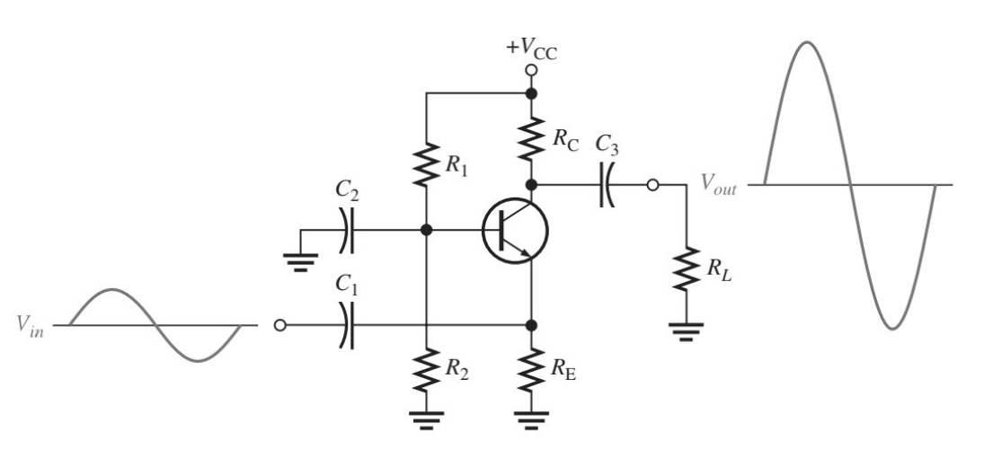

In a common base amplifier, the base is the common terminal, input is applied at the emitter and output is obtained from the collector. It has very low input impedance and very high output impedance.

**Common Collector Amplifier**

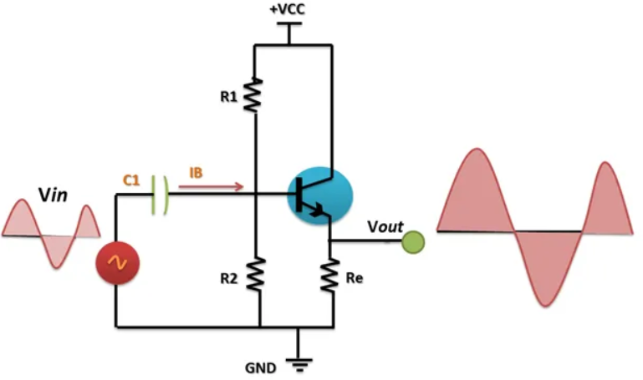

In common collector configuration, the collector is the common terminal. Input is applied at the base and output is measured at the emitter. It has high input impedance and low output impedance.

Circuit Diagrams

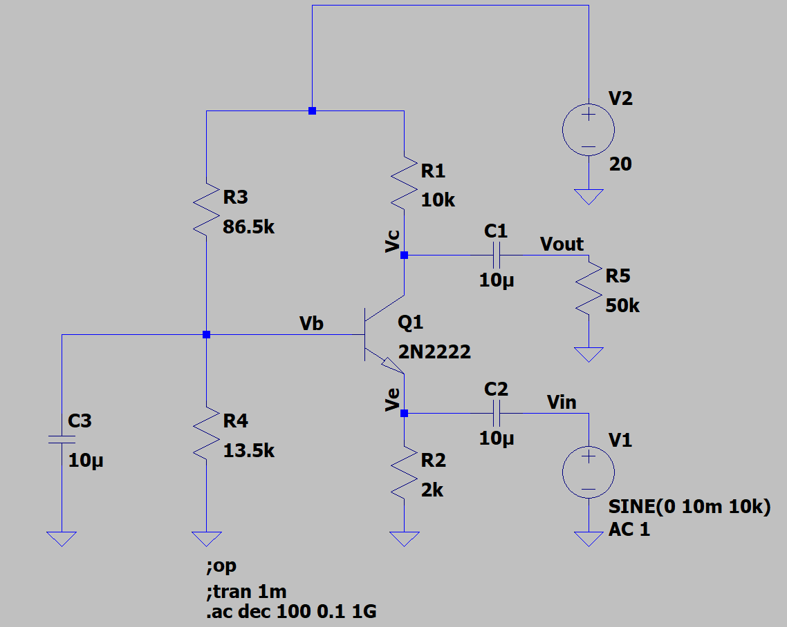 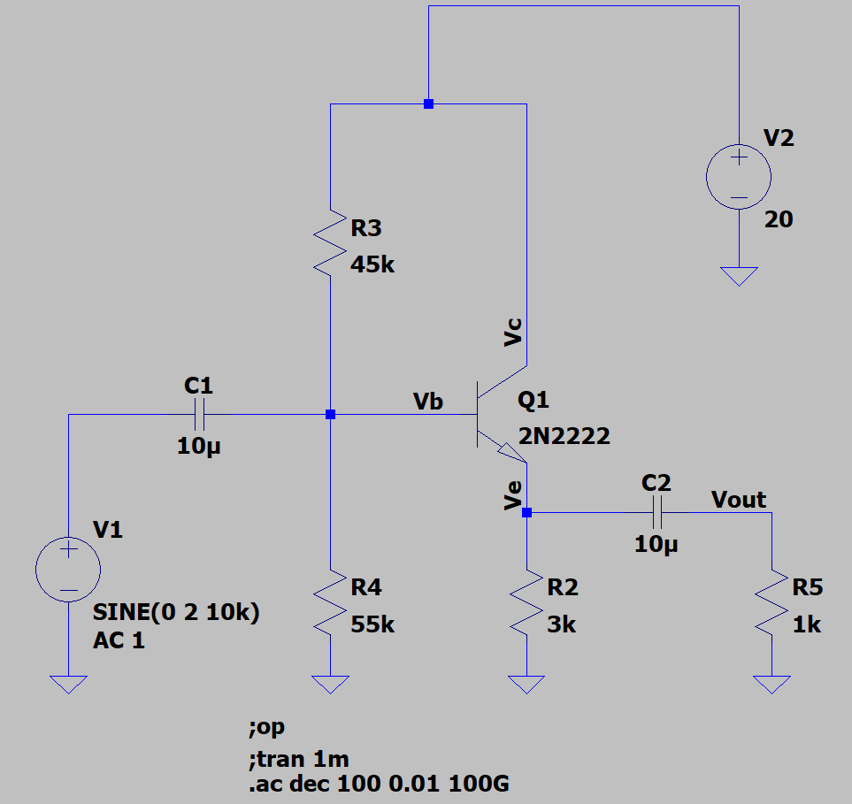

Observations

1. **Common Base Amplifier**
2. **Find out the DC operating point and check whether the circuit is in active region or not.**

It can be clearly seen that voltage at collector (**10.08V**) is more than the voltage at base (**2.64V**). The emitter voltage (**1.99V**) is lower than base voltage. This implies that the circuit is operating in active region.

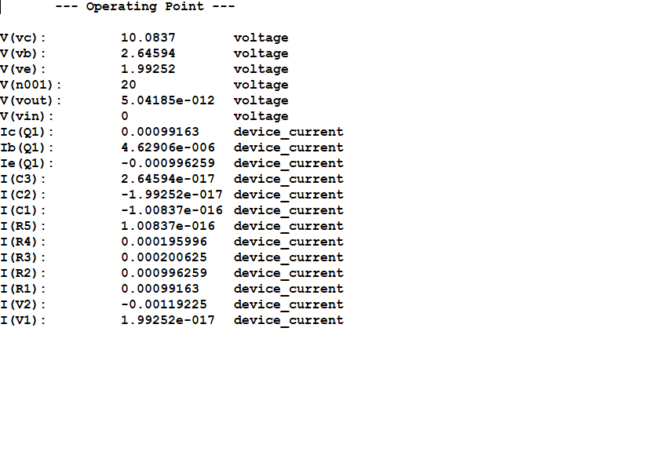

1. **Apply sine wave (peak to peak 20mV, 10 kHz) through a capacitor 10 μF at emitter. Plot input and out signal with respect to time with and without a capacitor 10 μF connected at collector of BJT.**

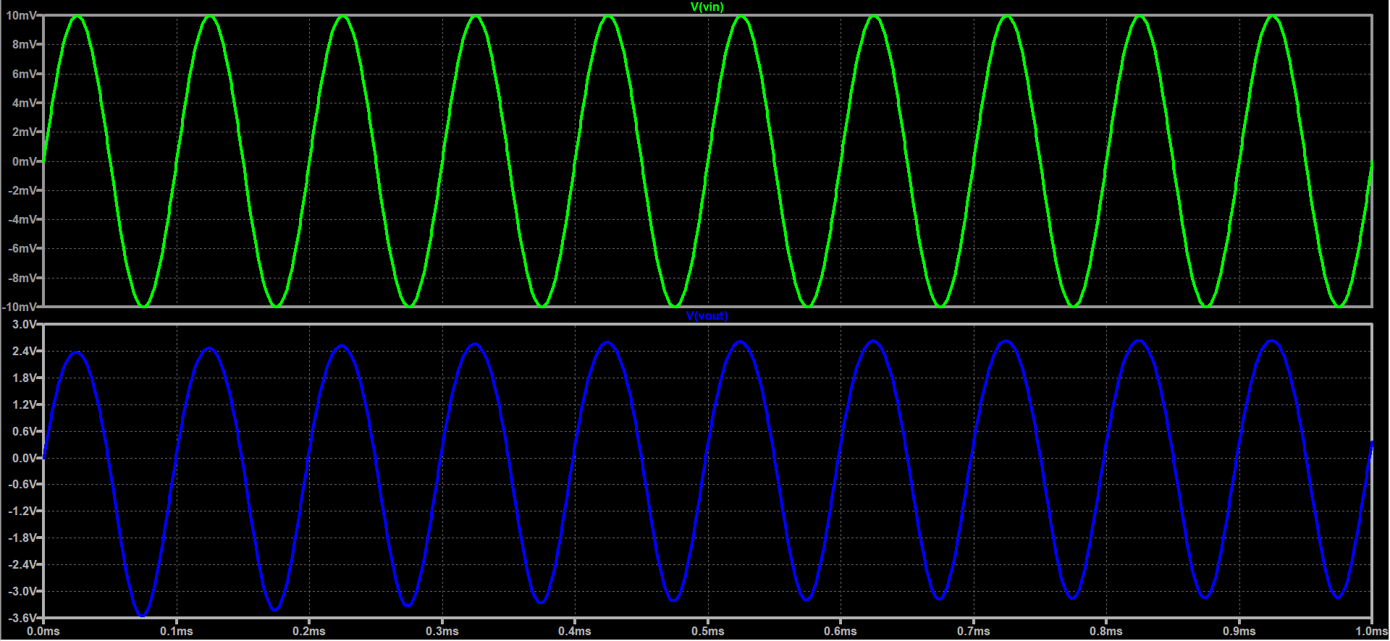

**With capacitor at output**

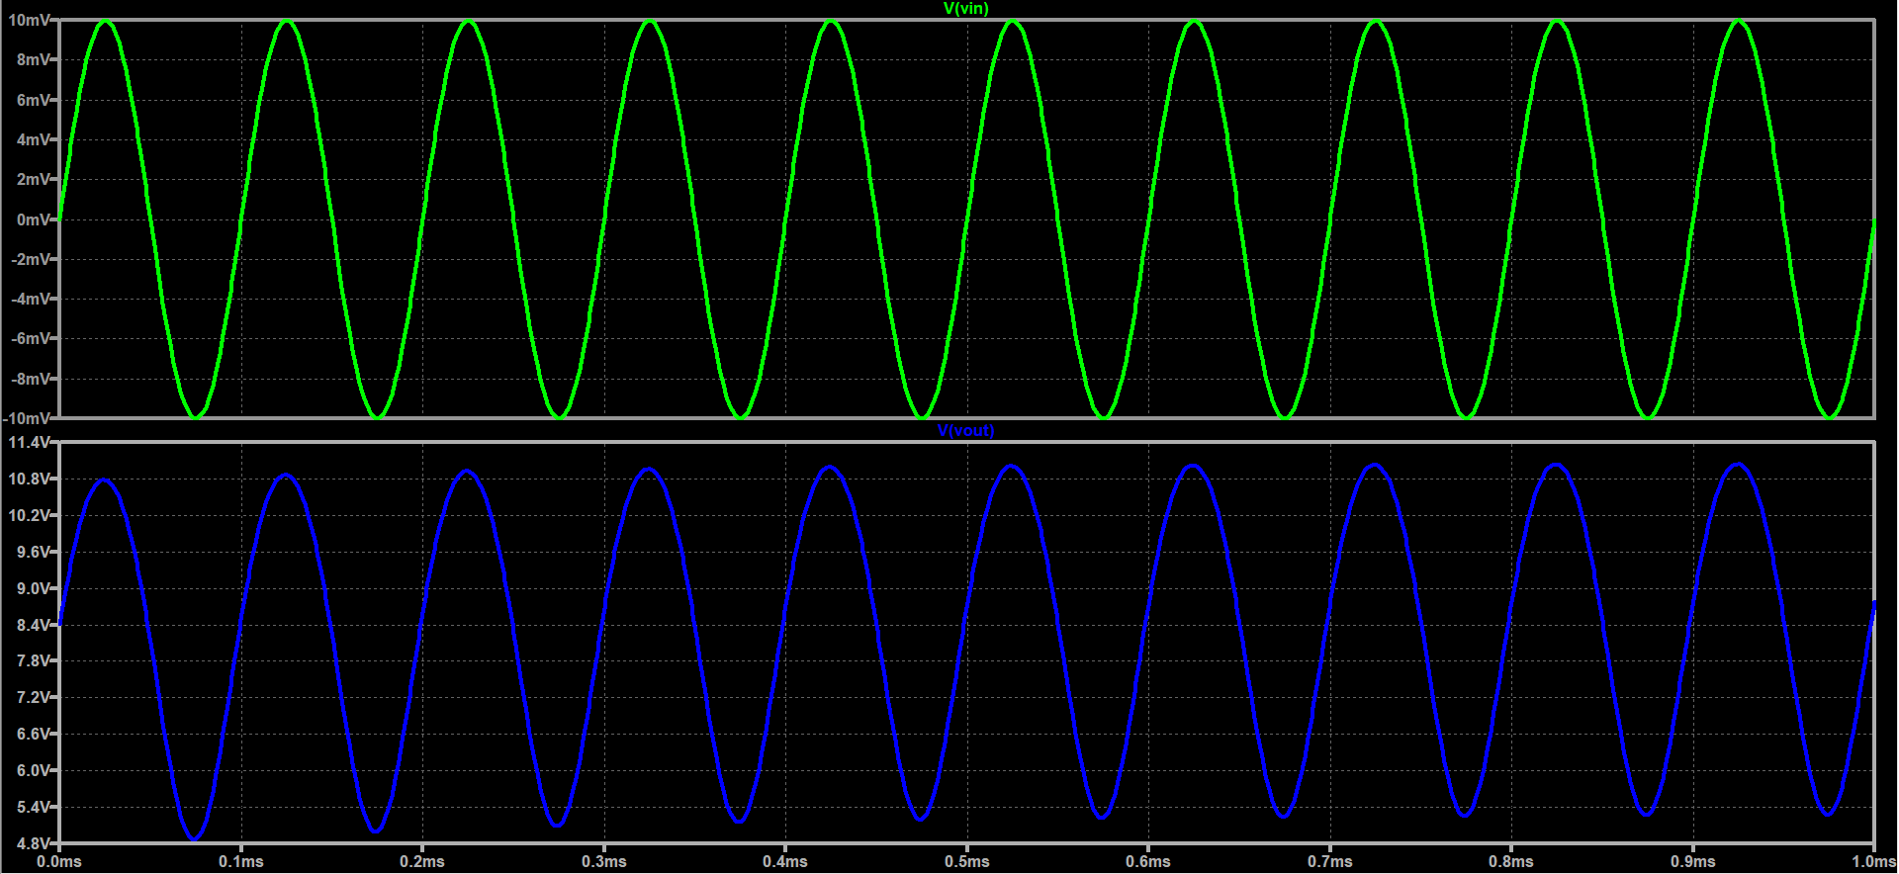

**Without capacitor at output**

1. **Plot Gain (dB) vs Frequency (500 Hz - 5 MHz).**

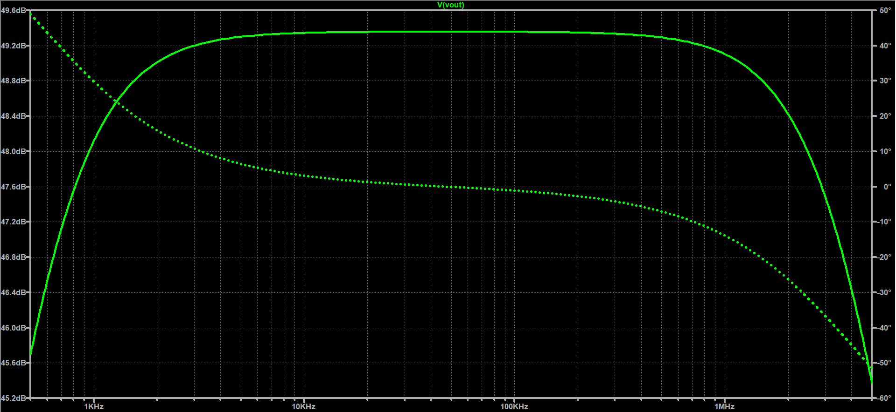

1. **Find the Bandwidth of the amplifier.**

The higher -3dB cutoff frequency is around 4.075 MHz. The lower -3dB cutoff frequency is 574 Hz. The bandwidth of the amplifier is 4.075 MHz as lower cutoff frequency is quite low.

1. **Common Collector Amplifier**
2. **Find out the DC operating point and check whether the circuit is in active region or not.**

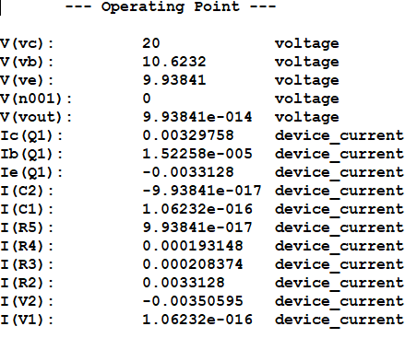

It can be clearly seen that voltage at collector (**20V**) is more than the voltage at base (**10.62V**). The emitter voltage (**9.93V**) is lower than base voltage. This implies that the circuit is operating in active region.

1. **Apply sine wave (peak to peak 4 V, 10 kHz) through a capacitor 10 μF at base. Plot input and output signal with respect to time. Output is measured at emitter of BJT. You may take RL = 1 KΩ.**

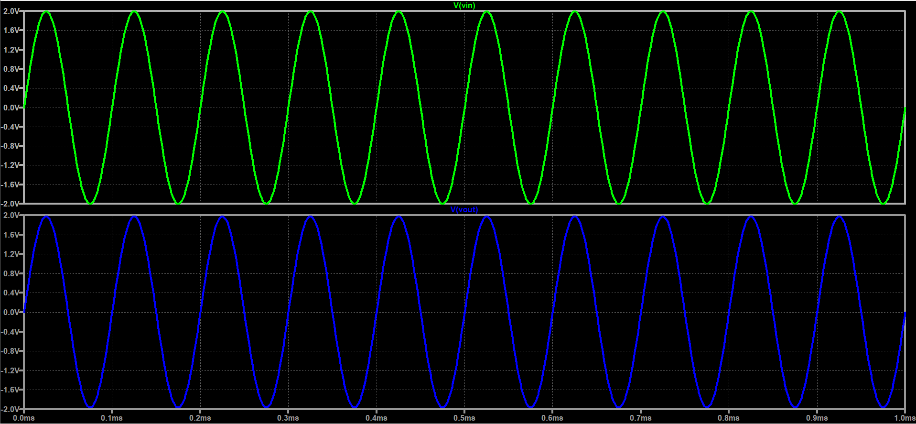

1. **Plot voltage Gain (dB) vs Frequency (50 Hz - 50 MHz).**

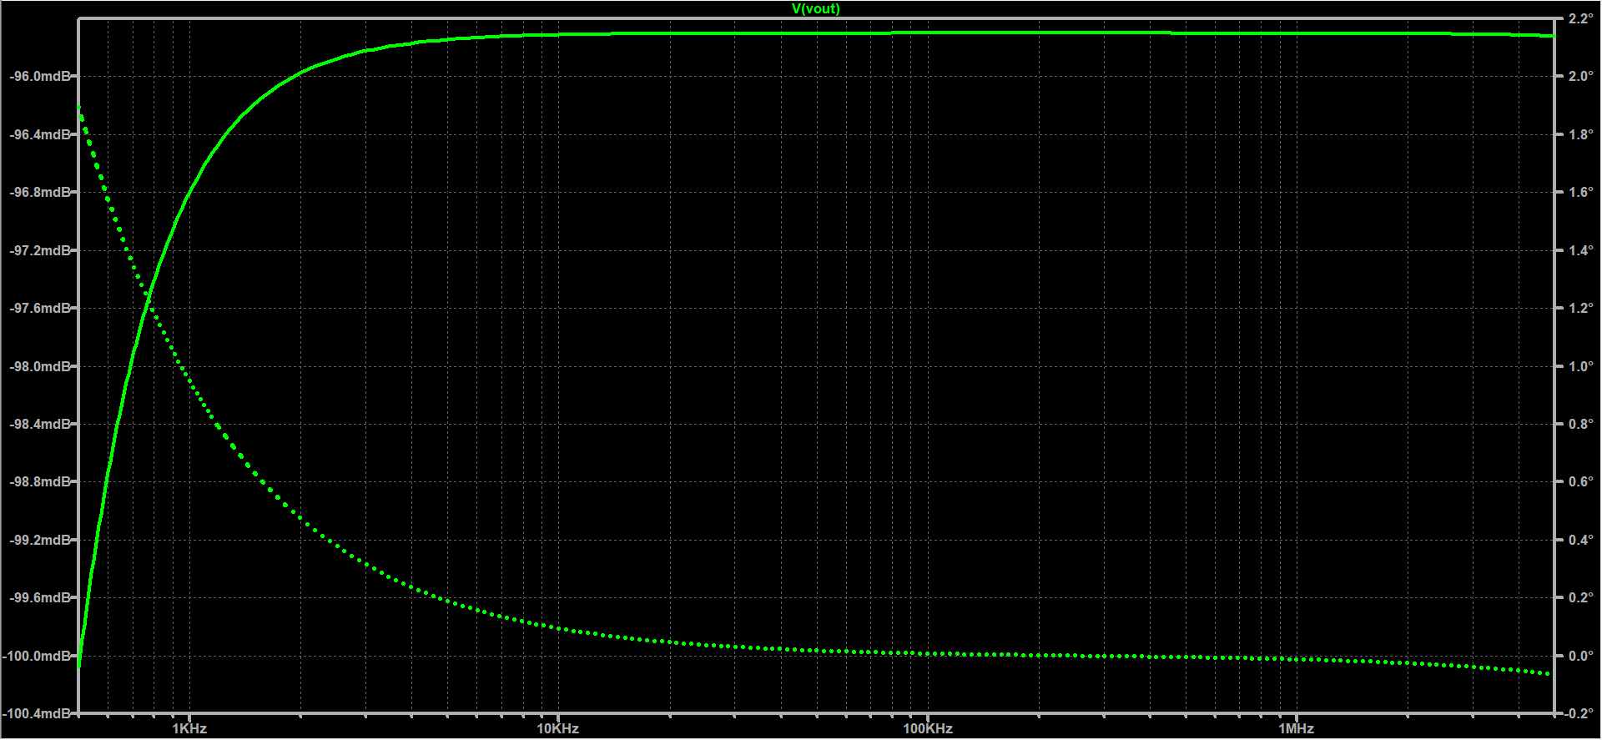

1. **Increase the frequency to check the bandwidth. Plot input current and output current and check the current gain of the circuit.**

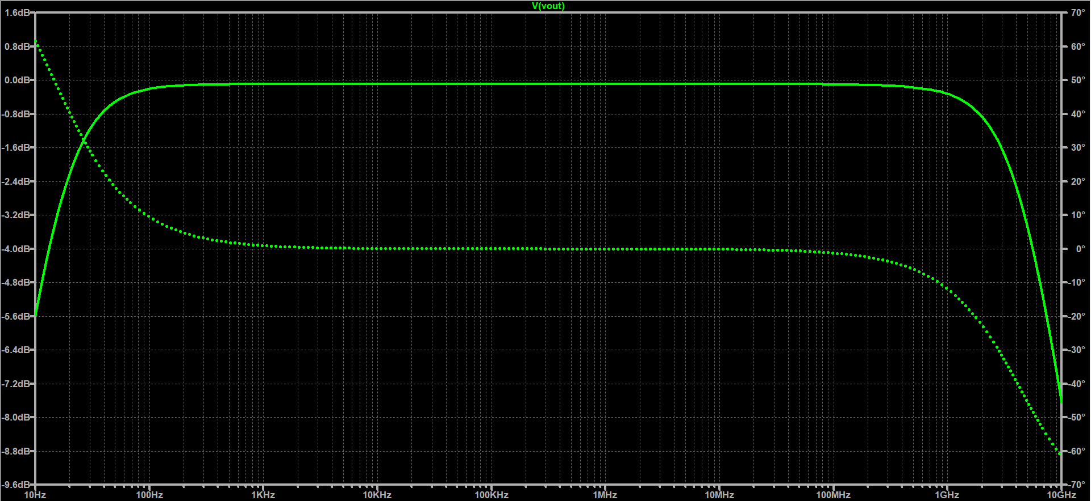

The higher -3 dB cutoff frequency is 4.582 GHz and the lower -3 dB cutoff frequency is 16 Hz. The bandwidth of the amplifier is 4.582 GHz.

Discussions

1. The common base amplifier has voltage gain given by

$$A_{v}=\frac{R_{c}}{\frac{1}{g_{m}}+R_{E}}$$

This implies that the amplifier is non-inverting as input and output signals are in phase.

1. The low input impedance suggests non-ideal signal source would not be able to apply any voltage to the input. Similarly, high output impedance means only a fraction of the output would come across load. Thus, practically CB is a poor amplifier configuration even though gain is high. It is generally used for impedance matching.
2. The common collector amplifier has voltage gain given by

$$A_{v}=\frac{R_{E}}{{\frac{1}{g_{m}}+R}_{E}}$$

Thus, the CC topology is also non-inverting as input and output signals are in phase.

1. The high input impedance and low output impedance make it perfect for connecting loads. However, since there is no amplification it is generally used as buffer circuit.

Results

|  |  |  |
| --- | --- | --- |
|  | CB Amplifier | CC Amplifier |
| DC Bias Point (V) | 10.0837 | 9.938 |
| Gain (dB) | 49.357 | -0.095 |
| Bandwidth (MHz) | 4.075 | 4582 |